Hoosier Canoe and Kayak: Getting started in Sea Kayaking

Sea Kayaking requires an appropriate kayak, specific gear, training and progressive experience.
Kayak Requirements
- Sea Kayaks are longer and narrower for better tracking, managing wind & waves and speed
- Length at least 14’, preferably 15”+
- Skeg or rudder for wind and weathercocking
- Airtight hatches Fore and Aft
- Perimeter deck lines (not bungee cord)
Safety Gear
- Spray Skirt
- Paddle float
- Pump
- Clothing for conditions (Cold water exposure)
Review Types of Water, Conditions, Distance and Expected Paddler Ability for SK trip
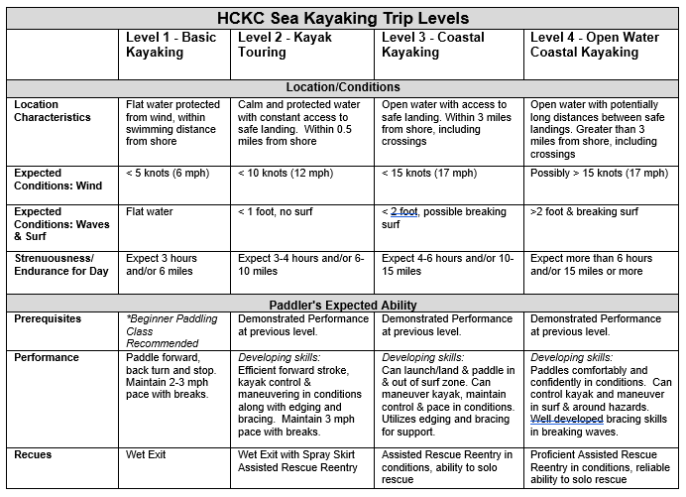
Get to Know HCKC Experienced SK Paddlers
- How did they learn?
- What gear/boat/paddles work the best?
- Experiences they learned from
Online Resources
- HCKC Web site SK Page
- HCKC Website Forum
- Facebook HCKC Page
- Endless information in Paddler.com, You Tube and other searches
Take Advantage of HCKC Training Opportunities
- Beginner & Intermediate Kayak Classes
- Open Water Rescue
- Open Water Rescue
- Pool Practice
- Tuesday Night Training Paddles at Eagle Creek
You cant learn it all at once so……..Participate and Practice, Practice, Practice

